Seasoned Analyst Toolbox
Reusable checklists templates queries tests strategies tactics and methods
A field reference for reliable business and data analytics work
This toolbox collects the reusable controls and working patterns that experienced analysts keep close. It is not a rigid process. Select the smallest set of artifacts and tests that protects the decision, then tailor them to the organization, risk, data, method, and deployment environment.

How to use the toolbox
- Before work begins, complete the intake and framing checklist.
- Before deep analysis, run the data profile, grain, join, and metric-definition checks.
- During analysis, choose methods from the decision table and maintain a decision and assumption log.
- Before publication, execute the validation, visualization, reproducibility, privacy, and peer-review checks.
- Before deployment, confirm ownership, training, monitoring, rollback, and benefits measurement.

Two ways to enter the work
Entry | First move | Minimum control before continuing
New project | Complete intake, decision statement, scope, stakeholder and data-access plan | Sponsor confirms the decision, value, boundary and acceptance criteria
Mid-project takeover | Preserve the current version, inventory artifacts and locate the project stage | Reproduce one critical number and agree on the restart point
Urgent request | Time-box framing and identify the smallest defensible answer | Decision, definition, grain, source, limitation and reviewer are explicit
Broken result | Return to the last trusted control and reconcile each transformation | Root cause and affected outputs are known before republishing

Mid project takeover checklist
- Confirm the decision owner, pending decision, real deadline and reason for the handoff.
- Copy or version the current files before changing logic.
- Inventory the brief, requirements, definitions, sources, access, queries, code, outputs, tests, decisions, risks and owners.
- Mark each item as confirmed, inferred, disputed or unknown.
- Identify the earliest missing essential artifact in the life cycle.
- Reproduce a published total from source through the current output.
- Test grain, keys, joins, filters, dates, units, metric logic and refresh timing.
- Document gaps by severity and decision impact.
- Agree with the sponsor on what continues, what is repaired, what pauses and who approves the next milestone.

Stage recovery matrix
Evidence missing | Return to | Recovery action
Decision or value | Business framing | Restate the decision, owner, deadline, alternatives and consequence
Scope or ownership | Planning | Rebuild boundary, RACI, backlog, acceptance and change log
Grain or definitions | Data preparation | Approve row meaning, keys, population, metric logic and dates
Reproducibility or tests | Analysis | Recreate run path, baseline, validation and peer review
Action or acceptance | Decision delivery | Rewrite options, recommendation, risks, owner and next action
Adoption or monitoring | Deployment and life cycle | Assign operational owner, thresholds, review cadence and rollback

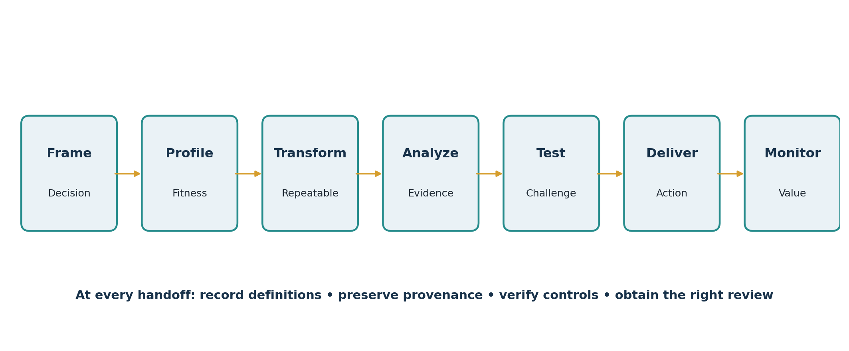
Figure 1 The experienced analyst’s control points

1 Project intake and triage
Check | Question | Artifact or action
Decision | Who decides what by when? | Decision statement
Value | What outcome, cost, risk, or opportunity changes? | Value hypothesis and baseline
Actionability | What feasible action could follow? | Candidate action list
Sponsor | Who owns priority, trade-offs, and acceptance? | Named sponsor and decision owner
Scope | What is included, excluded, and deferred? | Scope boundary and backlog
Data | Is relevant data available, authorized, and timely? | Source inventory and access request
Risk | Could error affect money, people, rights, safety, or compliance? | Risk tier and review plan
Delivery | What format, cadence, and acceptance criteria apply? | Definition of done

Fast intake template
- Because [current condition], [decision owner] must decide [decision] by [date].
- The decision matters because [business value or consequence].
- We will evaluate [alternatives] using [success measures] against [baseline].
- The analysis includes [scope] and excludes [boundary].
- The deliverable will be accepted when [testable criteria].
- Material assumptions, access needs, dependencies, and risks are [list].

Stop and escalate
- No accountable decision owner exists.
- The requested analysis would violate policy, privacy, law, contract, or professional ethics.
- A high-impact decision is being automated without meaningful human review.
- The requested precision exceeds the available data or method.
- Stakeholders expect the analyst to prove a predetermined conclusion.

2 Stakeholder discovery and meeting tools

Discovery agenda
1. Restate the business situation and decision.
2. Map the current process and failure points.
3. Confirm stakeholders, incentives, definitions, constraints, and prior attempts.
4. Separate facts, beliefs, assumptions, requirements, and preferences.
5. Confirm data sources, owners, grain, refresh, quality concerns, and access.
6. Agree on the next decision, artifact, owner, and date.
Technique | Use when | Output
Interview | Individual knowledge, sensitive concerns, or executive context matters | Confirmed notes, definitions, assumptions
Workshop | Teams must align on scope, process, priorities, or definitions | Shared model and decisions
Observation | Stated process differs from actual work | Current-state process and exceptions
Document analysis | Rules, contracts, reports, or prior requirements exist | Source-backed constraints and gaps
Prototype | Stakeholders cannot describe the needed output abstractly | Feedback on a concrete example
Decision log | Choices recur or accountability could become unclear | Decision, rationale, owner, date, consequences

Meeting note template
- Purpose and decision needed
- Attendees and roles
- Confirmed facts and definitions
- Assumptions and disagreements
- Decisions made and rationale
- Open questions and evidence needed
- Actions, owners, and dates
- Changes to scope, risk, or acceptance criteria

3 Data source inventory and data contract
Field | What to record
Source identity | System, table/file/API, environment, owner, steward
Purpose | Business process represented and intended analytical use
Grain | One row equals entity plus event/time detail
Keys | Primary, business, foreign, composite, and uniqueness expectations
Schema | Fields, types, allowed values, units, formats, nullable rules
Refresh | Event time, load time, cadence, latency, retention
Quality | Known defects, coverage, corrections, control totals
Security | Classification, permissions, privacy, consent, contractual limits
Lineage | Origin, transformations, filters, joins, derived fields
Service expectation | Availability, failure notification, owner, recovery path

Data contract tests
- Schema matches the expected names and types.
- Required keys are present and unique at the declared grain.
- Required fields satisfy null thresholds.
- Values fall within valid ranges and allowed categories.
- Dates are plausible, ordered correctly, and use documented time zones.
- Row counts, control totals, and freshness remain within expected tolerances.
- Breaking changes trigger an owner notification rather than silently changing results.

4 Reusable SQL profiling queries
Adapt syntax to the database. Replace names and thresholds deliberately; never run unbounded exploratory queries against production without authorization.

Row count date range and freshness
SELECT
COUNT(*) AS row_count,
MIN(event_ts) AS first_event,
MAX(event_ts) AS latest_event,
CURRENT_TIMESTAMP - MAX(event_ts) AS freshness_lag
FROM source_table;

Key uniqueness and duplicate detail
SELECT business_key, COUNT(*) AS rows_per_key
FROM source_table
GROUP BY business_key
HAVING COUNT(*) > 1
ORDER BY rows_per_key DESC;

Null and distinct-value profile
SELECT
COUNT(*) AS rows,
SUM(CASE WHEN customer_id IS NULL THEN 1 ELSE 0 END) AS null_customer_id,
COUNT(DISTINCT customer_id) AS distinct_customers,
MIN(amount) AS min_amount,
MAX(amount) AS max_amount
FROM source_table;

Join cardinality diagnostic
WITH left_keys AS (
SELECT join_key, COUNT(*) AS left_n FROM left_table GROUP BY join_key
), right_keys AS (
SELECT join_key, COUNT(*) AS right_n FROM right_table GROUP BY join_key
)
SELECT COALESCE(l.join_key,r.join_key) AS join_key, left_n, right_n,
COALESCE(left_n,0) * COALESCE(right_n,0) AS possible_join_rows
FROM left_keys l FULL OUTER JOIN right_keys r USING (join_key)
WHERE COALESCE(left_n,0) <> 1 OR COALESCE(right_n,0) <> 1;

Reconciliation by period
SELECT DATE_TRUNC('month', event_ts) AS month,
COUNT(*) AS records, SUM(amount) AS amount_total
FROM source_table
GROUP BY 1 ORDER BY 1;

Latest record per entity
SELECT * FROM (
SELECT t.*, ROW_NUMBER() OVER (PARTITION BY entity_id ORDER BY updated_at DESC) AS rn
FROM source_table t
) ranked
WHERE rn = 1;

5 Spreadsheet and Power Query controls
Need | Reusable pattern | Control
Structured range | Convert source to an Excel Table | No blank headers; unique column names; totals reconciled
Lookup | XLOOKUP with explicit not-found result | Count not-found records; confirm key uniqueness
Conditional total | SUMIFS or COUNTIFS | Reconcile against PivotTable/control query
Error trap | IFERROR only after cause is understood | Do not hide unexpected errors with zeros
Duplicate key | COUNTIF(key_column,current_key)>1 | Review business rule before removing
Refreshable preparation | Power Query steps with named queries | Document source, types, filters, merges, parameters
Scenario | Data Table, Goal Seek, or controlled assumption cells | Separate inputs, formulas, outputs; lock formula cells
Audit | Formula view, trace precedents, spot checks | Test boundary rows and totals

Power Query tactics
- Use the source-specific connector when available.
- Filter unnecessary rows and remove unused columns early.
- Set data types explicitly and inspect conversion errors.
- Name transformation steps by business meaning.
- Use parameters and custom functions for reusable logic.
- Perform expensive full-data operations after row-reducing steps when possible.
- Keep staging queries separate from final presentation queries.
- Verify row counts and unmatched keys after every merge.

6 Python and pandas validation patterns

Core assertions
assert len(df) > 0
assert df['order_id'].notna().all()
assert df['order_id'].is_unique
assert df['amount'].between(0, 1_000_000).all()
assert set(df['status'].dropna()).issubset({'open','closed','cancelled'})
assert df['event_date'].max() <= pd.Timestamp.today().normalize()

Merge with declared cardinality
result = orders.merge(
customers, on='customer_id', how='left', validate='many_to_one', indicator=True
)
assert (result['_merge'] == 'both').mean() >= 0.995
assert len(result) == len(orders)

Reusable data-quality test function
def test_dataset(df):
checks = {
'nonempty': len(df) > 0,
'key_complete': df['id'].notna().all(),
'key_unique': df['id'].is_unique,
'amount_valid': df['amount'].between(0, 1_000_000).all(),
}
failed = [name for name, passed in checks.items() if not passed]
assert not failed, f'Failed checks: {failed}'

Testing tactics
- Test normal, boundary, missing, duplicated, invalid, and empty cases.
- Parametrize repeated tests across columns, segments, or thresholds.
- Separate data tests from model-performance and business-outcome tests.
- Use a fixed small fixture for deterministic logic and a production-like sample for integration testing.
- Fail loudly on unexpected schema or cardinality changes.

7 Metric and KPI definition template
Definition field | Required content
Name and business meaning | Plain-language purpose and decision supported
Formula | Numerator, denominator, aggregation, weighting, rounding
Population | Included and excluded entities, filters, eligibility
Grain and dimensions | Level of detail and valid segmentation
Time | Event date, reporting period, timezone, refresh
Direction | Whether higher or lower is better; desired range
Reference | Baseline, target, threshold, benchmark
Owner | Definition owner, data owner, action owner
Controls | Source, reconciliation, tolerance, exception handling
Version | Effective date and approved changes

Metric review questions
- Could two competent analysts calculate different values from this definition?
- Does the denominator change with the decision context?
- Can the metric improve while the actual outcome worsens?
- What behavior might the metric unintentionally reward?
- Which segments or distributions could be hidden by the aggregate?
- What action follows when the metric crosses its threshold?

8 Method selection strategy
Decision need | Start with | Escalate when | Primary validation
Describe performance | Counts, rates, distribution, trend | Mix, cohorts, seasonality, or process stages matter | Reconciliation and denominator checks
Explain change | Variance bridge, funnel, cohort, segmentation | Alternative causes or interactions matter | Decomposition sums and robustness
Estimate relationship | Correlation and regression | Nonlinearity, selection, or dependence matters | Diagnostics and holdout tests
Predict | Simple rule or baseline model | Business value justifies added complexity | Out-of-sample accuracy and calibration
Choose action | Decision matrix and scenarios | Constraints and trade-offs require optimization | Sensitivity and feasibility
Estimate impact | Randomized experiment | Randomization is infeasible | Counterfactual credibility and pre-trend checks
Monitor | Thresholds and control chart | Adaptive or multivariate behavior matters | False-alert rate and response usefulness

Method selection checklist
- Question type and decision are explicit.
- Target, population, horizon, unit of analysis, and loss/cost of error are defined.
- Assumptions are plausible and testable.
- A simple baseline is documented.
- Sample size and representativeness are adequate for the claim.
- Deployment latency, interpretability, maintenance, and user workflow are considered.
- The method can be independently reviewed and monitored.

9 Testing and validation system
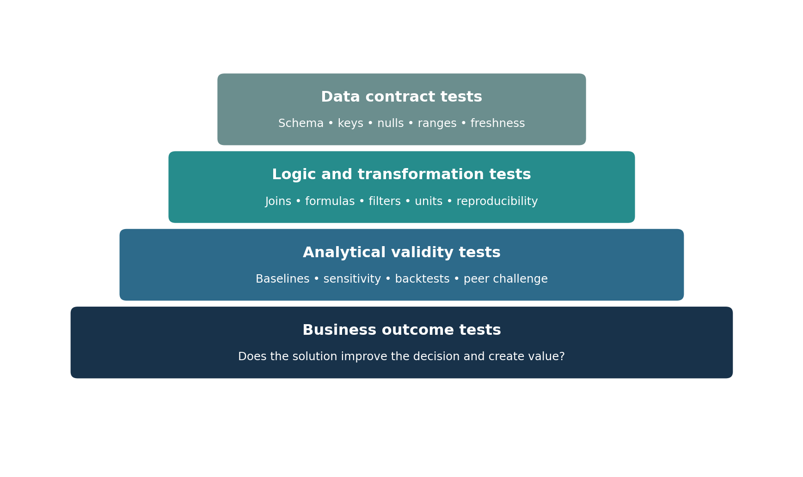
Figure 2 Layered testing from data contracts to realized value
Test family | Examples | Failure response
Data | Schema, keys, nulls, ranges, categories, freshness, control totals | Quarantine, correct source, narrow claim, or stop
Transformation | Join counts, formula checks, units, filters, aggregation, deterministic rerun | Fix logic and rerun downstream outputs
Analysis | Assumptions, baseline, holdout, sensitivity, alternative specifications | Revise method, qualify result, or gather data
Model | Discrimination, calibration, error by segment, stability, leakage, robustness | Retrain, simplify, constrain, or reject
Visualization | Labels, axes, denominators, filters, accessibility, source and refresh | Correct presentation and retest interpretation
Business | User acceptance, workflow fit, action rate, cost, benefit, unintended effects | Change solution, process, training, or retire

Red-team prompts
- What would have to be true for this result to be wrong?
- Which excluded population could reverse the conclusion?
- What alternative explanation fits the same evidence?
- Where could leakage, survivorship, seasonality, or Simpson’s paradox appear?
- Which assumption has the highest decision sensitivity?
- How could this metric or model be gamed?
- Who could be harmed even if average performance improves?

10 Visualization and dashboard review
Area | Review questions
Purpose | What decision, monitoring action, or exploration does this page support?
Audience | Does the terminology, detail, and interaction match the user?
Chart choice | Does the encoding match comparison, trend, distribution, relationship, or composition?
Integrity | Are axes, intervals, denominators, missingness, and uncertainty represented honestly?
Context | Are baseline, target, prior period, benchmark, filters, source, and refresh visible?
Hierarchy | Is the most important signal visually dominant without decoration?
Interaction | Do filters, drill paths, tooltips, and cross-highlighting behave predictably?
Accessibility | Are color contrast, labels, keyboard paths, alt text, and color-blind use considered?
Action | Are thresholds, owners, response, and escalation path known?
Performance | Are the data model, measures, queries, and number of visuals efficient?

Power BI semantic-model checks
- Separate fact tables for events/measures from dimension tables for filtering and grouping.
- Keep each fact table at a consistent declared grain.
- Prefer one-to-many relationships with a clear filter path.
- Create governed explicit measures for important calculations.
- Hide technical keys and raw columns that users should not aggregate.
- Use a proper date dimension and document role-playing dates.
- Test totals under multiple filters and combinations, not only the default page.

11 Reproducibility and peer review

Minimum reproducibility package
- README with purpose, owner, decision, dependencies, and run instructions.
- Source inventory and data-access assumptions.
- Data dictionary and metric definitions.
- Versioned queries, code, formulas, and configuration.
- Environment/package information where relevant.
- Validation results, control totals, and known limitations.
- Output version, refresh date, and release notes.
- AI-use record when material to code, evidence, interpretation, or deliverables.

Peer review checklist
- Reviewer can restate the decision and intended use.
- Raw inputs are preserved and transformations are traceable.
- Grain, keys, joins, filters, dates, and units are correct.
- Method matches the question and baseline.
- Tests cover expected and adverse cases.
- Claims do not exceed the evidence.
- Sensitive data and access are appropriate.
- Recommendation, uncertainty, owner, and next action are clear.

12 AI assisted analyst toolkit
Task | Useful instruction pattern | Mandatory verification
Discovery | Generate missing stakeholder questions from this decision statement; label assumptions | Sponsor and domain expert confirm context
SQL or code | Draft a solution using this schema and constraints; include tests and explain joins | Run in safe environment; inspect and reconcile
Data quality | Propose checks for grain, keys, nulls, ranges, freshness, bias, and leakage | Analyst selects thresholds and executes checks
Method critique | Compare methods against question, assumptions, interpretability, deployment, and cost | Qualified analyst validates technical claims
Red team | Attempt to disprove this conclusion using alternative explanations and edge cases | Analyst tests the strongest objections
Communication | Rewrite for this audience without changing numbers, uncertainty, or limitations | Compare line by line with verified evidence
Documentation | Draft dictionary, runbook, changelog, or test cases from supplied facts only | Owner reviews completeness and accuracy

AI safety gate
- Use is authorized and the tool is approved.
- Input data classification permits the use; secrets and protected information are controlled.
- The task and forbidden actions are explicit.
- Sources and provenance are preserved.
- Code, calculations, citations, and claims are independently verified.
- Bias, security, privacy, accessibility, and foreseeable harm are assessed.
- Material use is disclosed under applicable policy.
- A qualified human approves deployment and remains accountable.

13 Deployment monitoring and incident response
Control | Owner must define
Release | Version, environment, approval, dependencies, migration, rollback
Data monitoring | Freshness, schema, nulls, ranges, volume, control totals, alert thresholds
Model monitoring | Performance, calibration, drift, segment error, retraining trigger
Use monitoring | Adoption, overrides, action rate, user feedback, workflow exceptions
Risk monitoring | Bias, privacy, security, safety, complaints, policy changes
Value monitoring | Baseline, expected benefit, realized benefit, cost, benefit owner
Change control | Request, impact, review, approval, version, communication
Retirement | End-of-life trigger, archive, user notice, dependency removal

Incident triage
1. Contain: pause refresh, output, or automated action when continuing could cause harm.
2. Preserve: record time, version, input, logs, users, decisions, and observed impact.
3. Assess: determine severity, affected population, business consequence, and notification duty.
4. Correct: fix or roll back through approved change control.
5. Validate: rerun tests and obtain business sign-off.
6. Learn: document root cause, corrective action, control improvement, and owner.

14 Personal operating habits of a seasoned analyst
Habit | Practical behavior
Begin with the decision | Do not let a dashboard, dataset, or requested tool substitute for problem framing.
Write definitions early | Resolve grain, population, formula, time, units, and ownership before analysis expands.
Reconcile constantly | Keep known control totals and compare after each material transformation.
Preserve raw evidence | Make raw inputs read-only and maintain lineage to every published output.
Build the simple baseline | Complexity must demonstrate added decision value.
Invite disconfirmation | Ask peers and domain experts to find failure modes, not merely approve formatting.
Communicate uncertainty | State what could change the decision and what evidence would resolve it.
Close the loop | Follow the recommendation through adoption, outcome, side effects, and learning.
Automate stable work | Standardize repeated logic after definitions and judgment are settled.
Protect trust | Be accurate, transparent, ethical, and willing to stop unsafe or misleading work.

A weekly toolbox review
- What decision did my work improve this week?
- Which definition or assumption remains fragile?
- Which manual step should become a tested reusable pattern?
- Which result needs peer or domain challenge?
- Which stakeholder is surprised or disengaged?
- What data, model, dashboard, or decision now needs monitoring?
- What lesson should be added to the team’s checklist or template?

15 Source references
INFORMS Analytics Body of Knowledge. https://info.informs.org/abok
INFORMS Analytics Framework. https://www.informs.org/Professional-Development/INFORMS-Analytics-Framework/Explore
IIBA Guide to Business Data Analytics. https://www.iiba.org/career-resources/business-analysis-specialization/business-data-analytics/
IIBA BABOK Guide. https://www.iiba.org/career-resources/a-business-analysis-professionals-foundation-for-success/babok/
PMI PMBOK Guide Eighth Edition. https://www.pmi.org/standards/pmbok
Microsoft Power BI star schema guidance. https://learn.microsoft.com/en-us/power-bi/guidance/star-schema
Microsoft Power Query best practices. https://learn.microsoft.com/en-us/power-query/best-practices
PostgreSQL window functions. https://www.postgresql.org/docs/current/tutorial-window.html
pandas merge join concatenate and compare. https://pandas.pydata.org/docs/user_guide/merging.html
pytest parametrized tests. https://docs.pytest.org/en/stable/how-to/parametrize.html
The examples are generic teaching patterns. Adapt syntax, thresholds, security, validation, and governance to the actual platform and organizational policy. Use original professional standards and product documentation for complete requirements.

