Business and Data Analytics Master Playbook
Core concepts methods tools questions and project practices for a new analyst
A practical learning system for turning business questions into defensible decisions

This playbook is designed for a beginning analyst who needs to become useful quickly without learning bad habits. The central lesson is simple: analytics begins with a decision, not a dashboard. A strong analyst clarifies the business problem, obtains fit-for-purpose data, applies an appropriate method, tests the result, communicates the recommendation, and checks whether the decision created value.

Start here
Use this document as the main map for an analytics project. You do not need to read it from front to back before doing useful work. Choose the path that matches how you entered the project, complete the immediate actions, and then use the stage guide to find the right questions, artifacts, tools, and checks.
Your situation | Go first | Then use
Starting a new project | Section 0A Start to finish project path | Workbook Sections 1 through 10 and the Toolbox
Joining a project already underway | Section 0B Mid project takeover path | Quick Reference recovery checks and Toolbox validation patterns
Asked for a quick answer | Confirm the decision, definition, grain and deadline | Quick Reference before publishing
A result or dashboard looks wrong | Identify the last trusted stage and reconcile forward | Toolbox data, join, metric and testing sections
A term is unfamiliar | Terminology Guide | Return to the current stage after confirming the local definition
Unsure what to ask | Questions and Professional Answers | Use the question bank in Section 3

0A Start to finish project path
Stage | What you do | Required evidence | Ready to move on when
1 Frame | Clarify the decision, owner, outcome, deadline, scope and value | Confirmed problem and decision statement | The sponsor agrees on the decision and why it matters
2 Plan | Choose the approach, roles, milestones, risks and acceptance criteria | Project canvas, stakeholder map and backlog | Work is feasible, prioritized and governed
3 Prepare | Inventory, profile, clean and document sources, grain, keys and metrics | Source inventory, quality report and definitions | Material defects are corrected, bounded or disclosed
4 Analyze | Explore, compare, model and test alternative explanations | Reproducible analysis and validation results | The evidence is strong enough for the intended claim
5 Decide | Translate evidence into options, recommendation, risks and action | Decision brief, dashboard or presentation | The decision owner can act and understands uncertainty
6 Implement | Release the solution and support adoption | Release plan, training, ownership and rollback | Users can apply the output safely in their workflow
7 Learn | Monitor use, quality, performance, benefits and harm | Monitoring record and benefits review | The solution is improved, sustained or retired deliberately

0B Mid project takeover path
When you join midway, do not assume the existing output, code or dashboard proves that earlier decisions were sound. Reconstruct the chain from business decision to data to method to result. Preserve working materials, avoid changing production logic until you understand dependencies, and record what is confirmed versus assumed.
1. Orient: ask the sponsor what decision is pending, what deadline is real, and why you are joining now.
2. Inventory: locate the current brief, requirements, source data, definitions, queries or code, outputs, tests, decisions, risks and owners.
3. Locate the stage: identify what has been completed, what is active, what is blocked, and what has already been accepted.
4. Reconcile: reproduce one trusted control total from source to published output and test grain, keys, joins, filters, dates and metric definitions.
5. Assess fitness: compare the current method and evidence with the decision, risk and acceptance criteria; list gaps by severity.
6. Agree the restart point: tell the sponsor what can continue, what must be corrected, and what should be stopped before more work proceeds.
7. Stabilize and continue: update the plan, owners, decision log, tests and next milestone before changing the deliverable.
If you discover | Immediate response
No clear decision owner | Pause prioritization and obtain a named accountable owner
No agreed metric definition | Create and approve the definition before comparing results
Unknown data lineage | Trace one critical measure end to end and narrow claims until verified
Results cannot be reproduced | Freeze publication, preserve files and rebuild the run path
Scope changed informally | Record the change, impact and sponsor decision
High risk or policy concern | Stop the affected work and escalate through the approved channel

How to use this playbook
- Read Sections 1–4 first to learn the operating model.
- Use the question bank before every stakeholder meeting.
- Use the project canvas and checklists during live work.
- Complete the 30-day learning sprint and capstone in the workbook.
- Treat software as a means of producing trustworthy evidence, not as the definition of analytics.

Learning outcomes
- Frame ambiguous requests as decision-ready problem statements.
- Distinguish descriptive, diagnostic, predictive, prescriptive, and causal questions.
- Assess data quality, lineage, grain, bias, privacy, and fitness for use.
- Select and use Excel, SQL, Power BI, Tableau, Python, and supporting tools appropriately.
- Plan analytics work using practical PMBOK-aligned governance, scope, schedule, stakeholder, resource, finance, and risk practices.
- Translate findings into recommendations, actions, owners, measures, and learning loops.

1 The analyst operating system
The work is iterative. New evidence can change the question, and stakeholder feedback can reveal that the requested output is not the real need. Use the six-stage loop below as the default structure for every assignment.
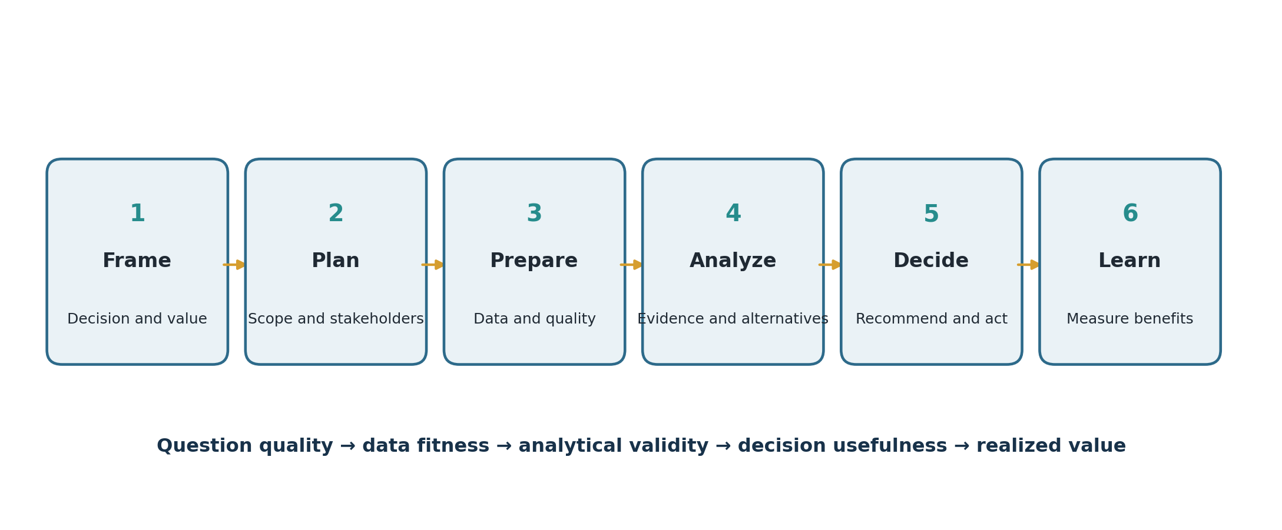
Figure 1 A decision-centered analytics workflow
Stage | Purpose | Minimum artifact | Exit question
Frame | Define the decision, value and boundary | Problem statement | Do we know who will decide what and why?
Plan | Agree scope, approach, stakeholders and controls | One-page project canvas | Is the work feasible, governed and prioritized?
Prepare | Acquire, profile, clean and document data | Data-quality report and dictionary | Is the data fit for this decision?
Analyze | Create evidence, alternatives and sensitivity tests | Reproducible analysis | Would the conclusion survive challenge?
Decide | Communicate recommendation and trade-offs | Decision brief or dashboard | Can a decision-maker act confidently?
Learn | Track adoption, benefits and unintended effects | Benefits review | Did the decision create value, and what changes next?

2 Core analytics concepts
Concept | Working definition | Analyst test
Business problem | A gap between current and desired outcomes, constrained by context | Can I state the gap, decision owner, value and deadline?
Requirement | A usable expression of a stakeholder need or constraint | Is it necessary, clear, testable and traceable?
Metric | A quantified measure; not automatically a decision criterion | Does its definition, grain, direction and owner exist?
KPI | A metric linked to a strategic objective and action threshold | What action follows when it changes?
Dimension | A categorical lens used to segment a measure | Can segments be interpreted consistently?
Grain | What one row represents | Can I say “one row equals…” without ambiguity?
Correlation | Variables move together | Could confounding, selection or coincidence explain it?
Causation | Changing one factor produces a change in another | Is identification supported by design or credible assumptions?
Forecast | A conditional estimate of a future value | What horizon, uncertainty and baseline apply?
Model | A simplified representation for explanation or prediction | How was it validated and where will it fail?
Insight | Evidence that changes understanding of a decision | Is it novel, material, credible and actionable?
Recommendation | A proposed action supported by evidence and trade-offs | Who should do what, by when, and how will success be measured?

Analytics question types
Type | Question | Typical methods | Common mistake
Descriptive | What happened? | Counts, rates, trends, segmentation | Reporting totals without context or denominators
Diagnostic | Why did it happen? | Drill-down, variance, cohorts, root cause | Treating correlation as proof
Predictive | What is likely next? | Forecasting, classification, regression | Hiding uncertainty or leakage
Prescriptive | What should we do? | Scenarios, optimization, decision analysis | Optimizing the wrong objective
Causal | What would happen if we intervene? | Experiments, quasi-experiments, causal inference | Using before-after change as causal proof

3 The questions a strong analyst asks
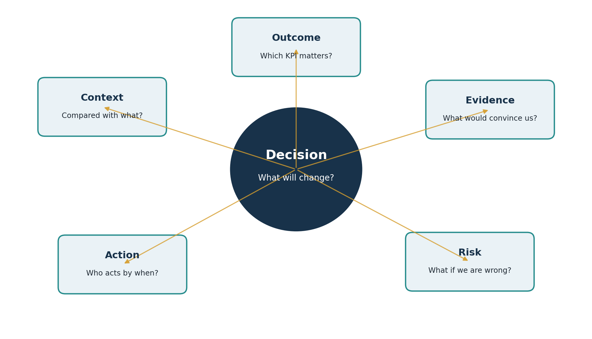
Figure 2 Questions should orbit the decision, not the available data

Decision and value
- What decision must be made?
- Who owns it, and who can veto or delay it?
- What outcome are we trying to improve?
- What is the cost of doing nothing?
- What action could realistically follow from the analysis?
- What deadline or decision window applies?

Scope and stakeholders
- Who is affected, consulted, responsible, accountable and informed?
- What is explicitly in scope and out of scope?
- What assumptions and constraints are non-negotiable?
- Where do stakeholders disagree about the problem or definition of success?

Measures and definitions
- What does success mean numerically and operationally?
- What is the baseline, target, threshold and comparison group?
- What is the numerator, denominator, unit, time window and grain?
- Can the same term mean different things across teams?
- Which leading and lagging indicators matter?

Data
- Where did the data originate and who owns it?
- Does one row represent the entity and time period we think it does?
- What is missing, duplicated, stale, censored or selectively captured?
- How are joins expected to behave?
- What transformations have already occurred?
- Are access, privacy, consent, security, retention or contractual limits involved?

Method and evidence
- What is the simplest method that can answer the question?
- What alternative explanation could produce this pattern?
- What benchmark, counterfactual or control is appropriate?
- What uncertainty or sensitivity test should be reported?
- Could seasonality, mix shift, survivorship, leakage or Simpson’s paradox mislead us?

Action and learning
- What recommendation follows, and what alternatives were rejected?
- What trade-offs, risks and dependencies accompany the action?
- Who will act, by when, using which resources?
- How will we measure adoption, benefit and unintended harm?
- When will we review the decision and update the model?

4 Business and data analytics stack
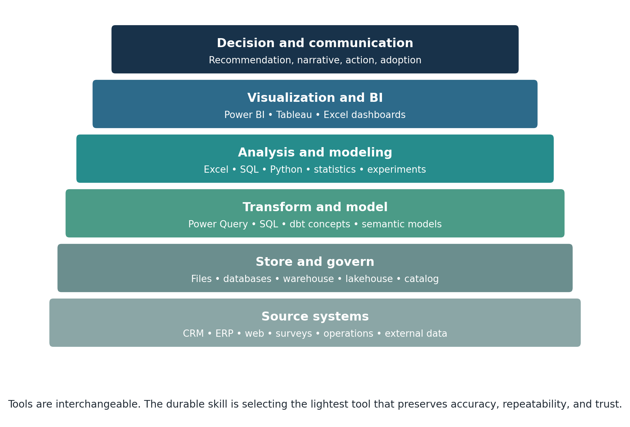
Figure 3 A practical analytics stack from source to decision
Tool or layer | Use it when | Learn first | Watch for
Excel | Fast exploration, small/medium tables, reconciliation, ad hoc models | Tables, XLOOKUP, SUMIFS, PivotTables, charts, Power Query | Hidden formulas, manual steps, version drift, row limits
SQL | Data lives in relational systems or repeatable extracts are needed | SELECT, WHERE, GROUP BY, JOIN, CTE, window functions | Join multiplication, NULL logic, wrong grain, unbounded queries
Power BI | Microsoft ecosystem needs governed interactive reporting | Power Query, star schema, relationships, DAX measures, filters | Calculated-column overuse, ambiguous relationships, weak semantic definitions
Tableau | Rapid visual exploration and highly interactive visual analysis | Dimensions/measures, level of detail, table calculations, actions | Beautiful but unactionable dashboards, aggregation surprises
Python | Automation, reproducibility, statistics, ML or large/complex transformations | pandas, notebooks/scripts, visualization, tests, environments | Notebook state, package drift, opaque code, overengineering
Databases and warehouses | Shared, scalable, governed analytical storage is required | Schemas, keys, indexing concepts, permissions, lineage | Copies without ownership, uncontrolled PII, unclear refresh
AI assistants | Drafting, code support, exploration and critique with human verification | Prompt specification, source checking, tests, disclosure | Hallucinations, data leakage, automation bias, unverifiable output
Git and documentation | Work must be reviewed, reproduced and changed safely | Commits, branches, README, data dictionary, changelog | Sensitive data in repos, meaningless commits, undocumented decisions

Selection rule: choose the lightest tool that can meet the required scale, repeatability, collaboration, security, governance, and auditability. Escalate tools only when a requirement justifies the added complexity.

5 Data preparation and quality
Quality dimension | Question | Typical check | Typical response
Completeness | Are required values present? | Null rate by field and segment | Recover source data, impute carefully, flag exclusions
Validity | Do values follow allowed rules? | Ranges, patterns, allowed categories | Correct mapping or quarantine invalid rows
Accuracy | Do values reflect reality? | Reconcile with trusted source or sample | Correct source process; document residual error
Consistency | Do systems and periods agree? | Cross-source and cross-field rules | Standardize definitions and master data
Uniqueness | Are entities duplicated? | Key uniqueness and fuzzy duplicate checks | Define survivorship and deduplication rules
Timeliness | Is data current enough? | Refresh lag and event-to-load time | Change cadence or qualify decision
Lineage | Can we trace origin and transformation? | Source-to-output mapping | Document queries, owners and transformations
Representativeness | Does captured data reflect the target population? | Coverage and selection comparisons | Weight, resample, narrow claims or collect more data

A repeatable preparation sequence
1. Define the target grain and keys before touching the data.
2. Preserve a read-only raw layer and create a working copy.
3. Profile row counts, types, ranges, missingness, categories and duplicates.
4. Standardize types, dates, units, labels and identifiers.
5. Resolve duplicates using an explicit business rule.
6. Join tables while comparing row counts and unmatched keys before and after.
7. Derive fields with documented formulas and assumptions.
8. Validate against control totals, samples and stakeholder expectations.
9. Publish a data dictionary, exception log and refresh date.

6 Analysis methods and critical thinking
Need | Useful methods | Critical thinking check
Size the problem | Counts, rates, distributions, Pareto | Use denominators and distinguish materiality from drama
Compare groups | Normalized rates, confidence intervals, effect sizes | Check selection, mix and sample size
Explain change | Variance bridge, cohort, funnel, decomposition | Separate mechanical drivers from causal claims
Find causes | Five Whys, fishbone, process map, hypothesis tree | Stop when evidence ends; verify root causes
Predict outcomes | Holdout validation, cross-validation, calibration | Compare with a simple baseline and prevent leakage
Choose an action | Decision matrix, scenarios, expected value, optimization | Make objectives, constraints and trade-offs explicit
Evaluate impact | Experiment, difference-in-differences, interrupted time series | Define counterfactual and pre-register measures when possible

The reasoning checklist
- Claim: What exactly am I asserting?
- Evidence: Which observation supports the claim?
- Warrant: Why does that evidence justify the claim?
- Alternatives: What else could explain it?
- Uncertainty: What do I not know, and could it change the decision?
- Boundary: Where and when is the claim expected to hold?
- Falsifier: What evidence would make me change my mind?
- Action: What should be done differently because of the finding?

7 Visualization and communication
Communication need | Preferred form | Rule of thumb
Compare categories | Sorted bar or dot plot | Start at zero for bars; order by meaning
Show trend | Line chart | Use consistent intervals and annotate material events
Show composition | Stacked bar for a few categories | Avoid many slices and decorative 3D charts
Show distribution | Histogram, box plot, density or dot plot | Do not replace distribution with an average
Show relationship | Scatterplot with relevant context | Do not imply causation; show segments and outliers
Monitor operations | Small dashboard with thresholds and owners | Every KPI needs definition, cadence and action path
Ask for a decision | One-page decision brief | Lead with recommendation, evidence, risk and next action

Decision brief structure
1. Decision requested and deadline.
2. Recommendation in one sentence.
3. Two to four pieces of decision-relevant evidence.
4. Alternatives considered and why they were not preferred.
5. Risks, assumptions, uncertainty and mitigation.
6. Action plan with owner, date, resource and success measure.

8 Project management for analytics
PMI’s PMBOK Guide Eighth Edition retains a principles-and-performance-domain foundation while making the guidance more actionable. For analyst work, translate its emphasis on value, tailoring and accountability into lightweight controls rather than unnecessary paperwork.
PMBOK-aligned domain | Analytics application | Lean artifact
Governance | Define decision rights, approval, ethics, privacy and change control | Project canvas and decision log
Scope | State deliverables, exclusions, acceptance criteria and change rule | Scope statement and backlog
Schedule | Time-box discovery, data access, analysis, review and rollout | Milestone plan or Kanban board
Finance | Estimate effort, tool/data cost, opportunity cost and expected benefit | Cost-benefit estimate
Stakeholders | Map influence, needs, resistance and communication cadence | Stakeholder map and communication plan
Resources | Assign skills, environments, access and reviewer capacity | RACI or responsibility matrix
Risk | Track data, method, adoption, security, schedule and value risks | Risk register with owner and response

Analytics project canvas
Field | Prompt
Decision | Who will decide what by when?
Value | Which outcome changes and how much might it matter?
Question | What research question and subquestions will guide the work?
Scope | What is included, excluded and deferred?
Deliverables | What will be produced, in what format, with what acceptance criteria?
Data | Sources, grain, owner, access, quality, privacy and refresh
Method | Planned analysis, baseline, validation and sensitivity checks
Stakeholders | Sponsor, decision owner, users, subject experts, data owners and reviewers
Plan | Milestones, dependencies, resources and review points
Risks | Probability, impact, trigger, response and owner
Action | Implementation owner, decision date and communication plan
Benefits | Baseline, target, benefit owner, review date and stop/change rule

Practical delivery rhythm
- Kickoff: confirm decision, value, scope, roles and access.
- Discovery: validate process, definitions, data lineage and hypotheses.
- Checkpoint: show early data profile and question risks before deep analysis.
- Working review: test logic with a peer and domain expert.
- Decision review: present recommendation, alternatives, uncertainty and ask.
- Benefits review: compare realized outcomes with baseline and capture lessons learned.

9 IIBA business analysis and business data analytics alignment
IIBA describes business data analytics as continuous exploration, iteration and investigation of past and current business data to produce insights that improve decisions. Its six practice domains provide a useful learning map. BABOK adds the surrounding business-analysis disciplines needed to plan, elicit, manage requirements, analyze strategy, define solutions and evaluate results.
IIBA business data analytics domain | Learner behavior | Evidence of competence
Identify the research questions | Translate a business need into answerable and prioritized questions | Decision statement, question tree and success measures
Source data | Locate, assess, obtain and govern relevant data | Source inventory, access record and quality profile
Analyze data | Choose techniques and produce reproducible evidence | Analysis file, assumptions and validation results
Interpret and report data | Explain meaning, uncertainty and limits for an audience | Narrative, chart set and decision brief
Use results to influence decision making | Connect evidence to alternatives, action and adoption | Recommendation, stakeholder plan and action log
Guide organization-level strategy | Improve capabilities, governance, ethics and portfolio value | Roadmap, standards and benefits measures

BABOK knowledge areas in everyday work
Knowledge area | Practical use
Business Analysis Planning and Monitoring | Choose the approach, stakeholders, governance, information management and improvement measures.
Elicitation and Collaboration | Prepare, conduct and confirm interviews, workshops, observation and feedback.
Requirements Life Cycle Management | Trace, maintain, prioritize, change and approve needs and designs.
Strategy Analysis | Understand current state, future state, risks and change strategy.
Requirements Analysis and Design Definition | Model, verify, validate, prioritize and recommend solution options.
Solution Evaluation | Measure performance, identify limitations and recommend changes that increase value.

10 INFORMS Analytics Body of Knowledge and Analytics Framework
INFORMS defines analytics as the scientific process of transforming data into insight for making better decisions. Its Analytics Body of Knowledge broadens the learner’s view beyond software by addressing decision-centric analytics, teams, data, methodology, modeling, machine learning, deployment, life-cycle management, and the organizational analytics ecosystem. The updated INFORMS Analytics Framework organizes applied work into seven connected, iterative domains and explicitly includes modern analytics and AI.
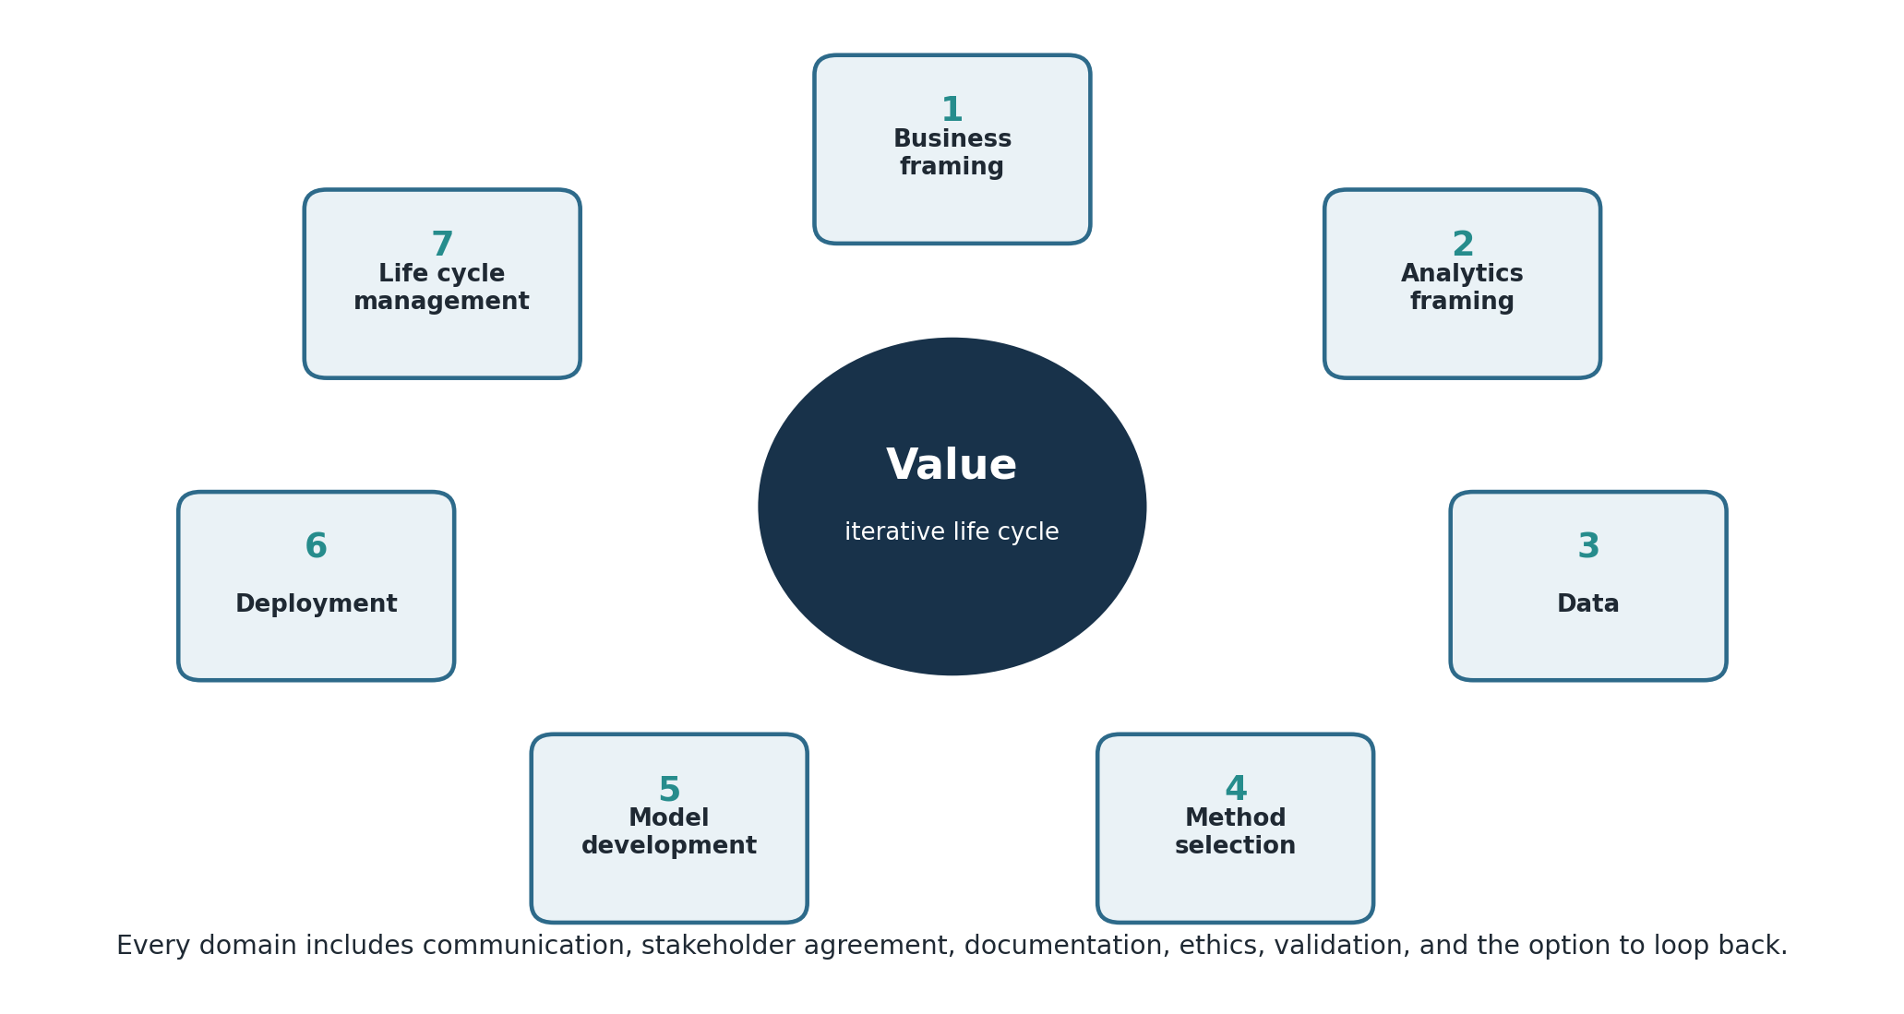
Figure 4 The seven connected domains of the INFORMS Analytics Framework
INFORMS domain | Core work | Beginner evidence
I Business problem question framing | Clarify the problem or opportunity, stakeholders, business case, scope and agreement | Decision statement, stakeholder map and value hypothesis
II Analytics problem framing | Translate the need into an analytical structure, drivers, assumptions, baseline and success measure | Question tree, analytical approach and acceptance criteria
III Data | Specify, acquire, clean, harmonize, validate and document fit-for-purpose data | Source inventory, data dictionary and quality report
IV Methodology approach selection | Choose methods, architecture, stack, environments and interface requirements based on context | Method comparison and solution design
V Analytics model development | Build, compare, validate and document models or analytical products; earn user trust | Reproducible analysis, validation report and user feedback
VI Deployment | Implement technically, train users, validate business fit and obtain sign-off | Release plan, training aid and business validation
VII Analytics solution life cycle management | Monitor performance, drift, value, side effects, documentation and retraining | Monitoring plan, benefit review and change log

How the professional frameworks fit together
Framework | Primary contribution | Use it to answer
INFORMS ABOK and Analytics Framework | Full analytics life cycle, modeling, deployment, sustained value, teams and organizational capability | Are we solving the right problem with the right method and sustaining the solution?
IIBA Guide to Business Data Analytics | Research questions, data sourcing, analysis, interpretation, influence and organization-level strategy | How do we turn business data into insight and influence a decision?
BABOK Guide | Business analysis planning, elicitation, requirements, strategy, design and solution evaluation | What does the organization need, and how should change be defined and evaluated?
PMBOK Guide | Value delivery, governance, scope, schedule, finance, stakeholders, resources, risk and tailoring | How do we organize, govern and deliver the initiative successfully?

These frameworks are complementary. The practical workflow in this playbook is a teaching synthesis, not a replacement for any source standard. Use the original publications for certification study, formal terminology, and complete task guidance.

11 AI assisted analytics with human accountability
AI tools can accelerate research, data preparation, coding, analysis, visualization, documentation and critique. They can also fabricate facts, expose confidential data, reproduce bias, generate insecure code and encourage overconfidence. The analyst remains accountable for every material claim, decision and deployed output.
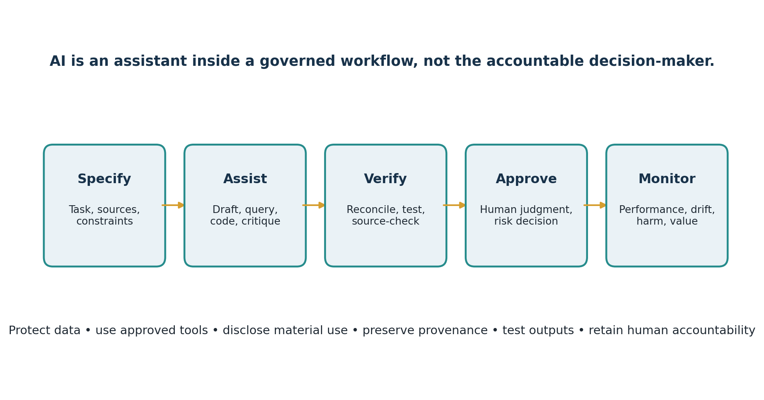
Figure 5 A governed workflow for using AI in analytics
Analytics stage | Productive AI use | Required control
Problem framing | Generate stakeholder questions, alternative problem statements and assumption lists | Decision owner confirms scope, value and wording; do not let AI invent business context
Data | Draft profiling code, transformation logic, dictionaries and test cases | Use approved environments; remove protected data; reconcile counts and inspect samples
Method selection | Compare candidate techniques, assumptions, trade-offs and baselines | Qualified analyst chooses the method and checks technical claims against authoritative sources
Analysis and modeling | Draft SQL, formulas, Python, DAX, documentation and adversarial tests | Execute safely; review code; test edge cases, leakage, bias, robustness and reproducibility
Communication | Improve plain-language explanations, chart titles, summaries and audience adaptation | Trace every statement to evidence; disclose material AI use; avoid invented citations
Deployment | Draft runbooks, training, monitoring rules and incident scenarios | Human approval, access control, versioning, rollback, security review and user validation
Life-cycle management | Summarize logs, detect potential drift patterns and propose review questions | Humans set thresholds, investigate alerts, assess harm and authorize changes

AI appropriate use checklist
- Authority: the use is allowed by organizational, course, client and legal policy.
- Data protection: confidential, personal, regulated and proprietary data stay in approved systems.
- Purpose: AI is used for a defined task with constraints and an accountable owner.
- Provenance: sources, prompts, model/version when available, edits and decisions are documented when material.
- Verification: calculations, citations, code, joins, assumptions and outputs are independently tested.
- Fairness and harm: affected groups, bias, accessibility and foreseeable misuse are considered.
- Transparency: material AI contribution is disclosed to the appropriate audience.
- Human approval: a qualified person remains responsible for decisions and deployment.
- Monitoring: performance, drift, incidents and realized value are reviewed after release.

12 Common pitfalls errors and recovery
Failure pattern | Symptom | Recovery
Solution-first thinking | Request starts with “build a dashboard” but no decision is named | Ask what action or choice the output must support.
Wrong grain | Totals inflate after a join | State row grain; test key uniqueness and row counts before/after joins.
Metric ambiguity | Teams report different values for the same KPI | Create governed definition with formula, filters, owner and effective date.
Cherry-picking | Only favorable segments or periods are shown | Predefine comparisons and show robustness across plausible choices.
Correlation as causation | Recommendation assumes a driver was proven | Use cautious language, test alternatives, or design causal evaluation.
Data leakage | Predictive accuracy collapses in production | Rebuild features using only information available at prediction time.
Dashboard overload | Many visuals but no clear priority or action | Reduce to decision-relevant KPIs, thresholds, owners and drill paths.
Manual fragility | Copy-paste process breaks each month | Use tables, queries, scripts, refresh checks and documentation.
AI automation bias | Plausible output is accepted without evidence | Require sources, tests, reconciliation, peer review and disclosure.
Scope creep | New questions continuously delay delivery | Use backlog, change decision, impact estimate and sponsor priority.
Stakeholder surprise | Decision owner rejects correct analysis late | Schedule early checkpoints and confirm definitions with real examples.
No value follow-through | Output delivered but behavior and outcomes do not change | Assign implementation and benefit owners with dated reviews.

13 Frequently asked questions
Do I need advanced math? Not to begin. You need numerical literacy, logic, basic statistics and the discipline to match method to question. Learn deeper mathematics as the problems require it.
Which tool should I learn first? Excel and SQL provide the fastest broad foundation. Add one BI tool, then Python when repeatability, scale, statistics or automation justify it.
Power BI or Tableau? Choose the platform used by your organization. The durable skills are data modeling, visual reasoning, interaction design, KPI governance and decision communication.
When should I use Python instead of Excel? Use Python when steps must be automated, reviewed, tested or scaled beyond comfortable spreadsheet use. Do not use it merely to make a simple task look sophisticated.
How clean must data be? Clean enough for the decision, with known limitations. Fitness for use matters more than perfection; material defects must be fixed, bounded or disclosed.
What if stakeholders do not know what they want? Start with the decision, process, pain, current workaround and consequences. Prototype questions and outputs, then confirm with examples.
How do I know an insight is good? It is credible, material, relevant, understandable and capable of changing a decision or action.
How do I validate my work? Reconcile totals, inspect samples, test edge cases, compare with baselines, obtain peer and domain review, and reproduce the output from raw inputs.
Can I use AI? Yes, if policy permits and you protect confidential data. Treat AI as an assistant: specify the task, require evidence, test outputs, disclose meaningful use and keep human accountability.
What belongs in a portfolio? Show the problem, decision, data, method, validation, recommendation, limitations and measurable result—not only screenshots of a dashboard.

14 Learning pathway and tasks
Week | Focus | Practice task | Deliverable
1 | Decision framing and questions | Turn three vague requests into decision statements and question trees | Three one-page problem frames
2 | Excel and data quality | Profile and clean a messy operational table | Clean table, exception log and PivotTable
3 | SQL and relational thinking | Query customers, transactions and products; test joins | Commented SQL and reconciliation sheet
4 | Analysis and statistics | Compare segments and explain a performance change | Analysis memo with uncertainty
5 | Power BI or Tableau | Build a decision-focused dashboard | Three-page maximum dashboard and metric dictionary
6 | Python and reproducibility | Automate one repeated preparation or analysis task | Script/notebook with tests and README
7 | Business analysis and project control | Run a mock discovery and build the project canvas | Canvas, stakeholder map, backlog and risk register
8 | Capstone decision | Complete end-to-end analysis and executive review | Decision brief, reproducible work and benefits plan

Capstone standard
- Use a realistic decision with at least two plausible alternatives.
- Document the research questions, definitions, data grain, quality and limitations.
- Use at least two tools appropriately, not artificially.
- Include independent validation or peer review.
- Present a recommendation, expected value, risk, implementation owner and review date.
- Submit a short reflection explaining what evidence changed your original view.

15 Professional habits and ethics
- Keep raw data immutable and separate from transformed outputs.
- Record definitions, assumptions, filters, exclusions and decisions as you work.
- Use least-privilege access and never place sensitive data in unapproved tools.
- Distinguish fact, inference, forecast, judgment and recommendation.
- Report uncertainty and material limitations where they affect the decision.
- Invite challenge; a useful review tries to disprove the result.
- Optimize for organizational value and stakeholder outcomes, not output volume.
- Close the loop by measuring adoption, benefits and unintended consequences.

16 References and further study
Project Management Institute. A Guide to the Project Management Body of Knowledge PMBOK Guide Eighth Edition. Six principles, seven performance domains, and expanded AI, PMO and procurement coverage. https://www.pmi.org/standards/pmbok
International Institute of Business Analysis. Guide to Business Data Analytics and CBDA practice domains. https://www.iiba.org/career-resources/business-analysis-specialization/business-data-analytics/
International Institute of Business Analysis. BABOK Guide overview and six business analysis knowledge areas. https://www.iiba.org/career-resources/a-business-analysis-professionals-foundation-for-success/babok/
INFORMS. Analytics Body of Knowledge overview covering the process, design and execution of analytics. https://info.informs.org/abok
INFORMS. Analytics Framework seven-domain iterative life cycle, updated for modern analytics and AI. https://www.informs.org/Professional-Development/INFORMS-Analytics-Framework/Explore
INFORMS. Certified Analytics Professional resources and vendor-neutral full-life-cycle competency framework. https://www.certifiedanalytics.org/
Microsoft Learn. Training for data analysts and Power BI learning resources. https://learn.microsoft.com/en-us/training/career-paths/data-analyst
This learning guide summarizes and adapts professional practices for instruction. It is not a substitute for the copyrighted standards, certification handbooks, organizational policies, or formal training materials.

