Analyst Quick Reference Field Guide
Questions checks tools and recovery moves for day-to-day analysis
A practical learning system for turning business questions into defensible decisions

Use this guide before meetings, before publishing results, and whenever the work feels stuck. If time is short, protect the decision, data grain, validation and action plan first.

Choose your entry point
If you are | Do these first
Starting from the beginning | Confirm decision, owner, value, scope and deadline; then build the project canvas.
Joining in the middle | Preserve current work; inventory artifacts; locate the stage; reproduce one trusted number; agree the restart point.
Only asked to analyze data | Ask what decision the analysis supports, what one row means, and which definition and deadline apply.
Troubleshooting an existing result | Start at the last trusted control and reconcile forward through filters, joins, calculations and refreshes.
Preparing to publish | Run the Before you publish checklist and obtain the required business and technical review.

The project in one page
Stage | Primary question | Minimum output
Frame | What decision and value are we supporting? | Decision statement
Plan | Who does what, by when, under which controls? | Canvas and plan
Prepare | Is the data fit and understood? | Quality report and definitions
Analyze | What does the evidence support? | Reproducible analysis
Decide | What should happen next? | Recommendation
Implement | Can people use it safely? | Release and adoption plan
Learn | Did it work and what changes? | Monitoring and benefits review

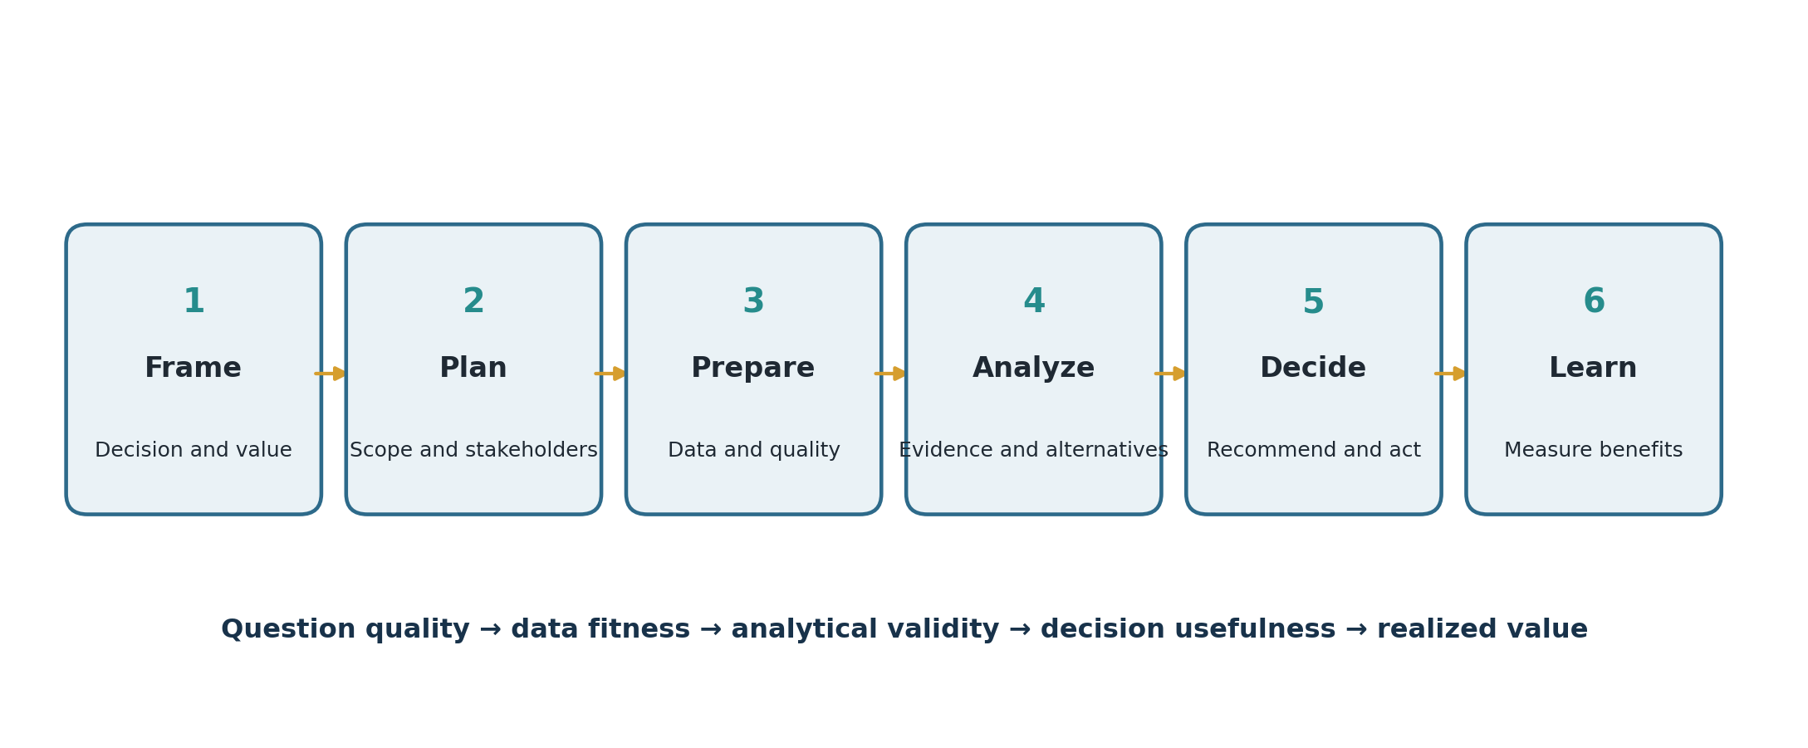
The six-stage analyst loop

The first ten questions
1. What decision must be made?
2. Who owns the decision?
3. What outcome and KPI matter?
4. What action could follow?
5. What is the baseline and target?
6. What is in and out of scope?
7. What does one row represent?
8. What could make the data misleading?
9. What alternative explanation could fit the evidence?
10. Who acts by when, and how will value be measured?

Tool choice in 30 seconds
Need | Start with | Escalate when
Explore or reconcile a manageable table | Excel | Steps repeat, data grows, or controls require code/query
Retrieve or combine relational data | SQL | Complex modeling or automation is needed
Share governed interactive metrics | Power BI or Tableau | Custom application or advanced modeling is needed
Automate, test, model or scale | Python | Production engineering requires a managed pipeline
Draft, critique or explain | Approved AI assistant | Never escalate accountability; verify everything material

INFORMS life cycle check
Domain | Fast check
Business framing | Is the real decision, value, sponsor and scope agreed?
Analytics framing | Are the analytical question, baseline, constraints and success measure clear?
Data | Is the data fit, documented, authorized and representative?
Method selection | Does the method fit the question, data, skills and deployment context?
Development | Was the output validated, compared, documented and reviewed with users?
Deployment | Are production, training, adoption, validation and sign-off covered?
Life cycle | Who monitors performance, drift, side effects, value and retirement?

AI use in 30 seconds
- Use only approved tools and approved data.
- Specify the task, evidence, constraints and forbidden actions.
- Treat output as an unverified draft until calculations, code and sources pass independent checks.
- Record material AI use and preserve enough provenance for review.
- Assess bias, privacy, security and foreseeable harm; keep a qualified human accountable.

Before you publish
- Decision and audience are explicit.
- Definitions, grain, filters and time window are visible.
- Counts reconcile to a trusted control.
- Joins, nulls, duplicates and outliers were tested.
- A simple baseline and alternative explanations were considered.
- Uncertainty and material limitations are disclosed.
- Charts answer a question and avoid misleading encodings.
- Recommendation includes owner, date, measure and risk.
- Another person can reproduce or review the result.

When something breaks
Symptom | First checks
Totals doubled | Join cardinality, key uniqueness, filters and grain
Numbers differ by tool | Definitions, refresh time, filters, types, rounding and timezone
Model looks too accurate | Leakage, target proxy, duplicates, split method and benchmark
Dashboard is ignored | Decision owner, action path, cadence, trust and workflow fit
Stakeholders disagree | Term definitions, incentives, decision rights and examples
Project will not end | Scope baseline, backlog, change impact and sponsor priority

One-sentence templates
- Problem: “Because [current condition], [stakeholder] cannot [decision or action], causing [measurable consequence].”
- Question: “For [population and time], how does [outcome] vary with [factor], compared with [baseline], to support [decision]?”
- Recommendation: “We recommend [action] for [scope] by [date] because [evidence], with [risk] managed by [mitigation].”
- Insight: “[Observed pattern] matters because [business implication], so [decision owner] should [action].”

